**DR1 Draft**

**Motor characterisation**

The motor needed for build our buggy should not exceed some limitations:

The maximum voltage that will be provided to the motor will be approximately between 3 and 5 volts. The final circuit will send a signal to the motor within this range and the power supply need to send enough power to feed not only the 2 motors but also all the electronic elements of the buggy. In addition, the current must be enough to overcome the stall position of the buggy and go up through the ramp on the race day. However, the maximum current demand needs to fit with the provided one by the circuit and if it is too high a big drop of voltage will occur in the leads. It is necessary to find a balance between the current need for make our buggy to move and go through the ramp and all the current that the batteries can supply. Batteries running out in the middle of the race will not be acceptable.

To calculate the armature resistance, the motor was stalled, applying a start voltage of 1 volt and a protection current limit of 1.7 amps, measurements were taken increasing each time 0.25 V until the current limit is reached. Using the formula from the technical handbook, equation 9, page 24:

$$V=K_{E}ω+IR+V_{b} (Eqn. ??)$$

$$I=\frac{V-V_{b}}{R}-\frac{K_{E}ω}{R}$$

Where $K_{E}ω=0$, i.e. motor is stalled;

$$I=\frac{V-V_{b}}{R} (Eqn.??)$$

Graph??

Armature Resistance=2.42Ω

Graph??

Graph??

**Load measurements:**

**How does this section relate to the rest of the report?:**

The aim of the experiment is to know the required force and hence the torque to move the buggy from stationary and at constant speed through both stages of flat surface and ramp in the examination. By completing the load experiment and using the results to calculate the static and rolling coefficient of friction, **the Force to move any buggy mass can be calculated**, hence the torque.

**Once the torque is known:**

**Current and voltage:**

The current and power supply voltage required to move buggy can be calculated; **see mathematical relationship in Gear ratio section.**

**Required Gear ratio:**

The Gear ratio can be selected as the selection is based on the compromise of both providing enough torque at the wheels for buggy to move through greatest resistance and still have significant speed. **See mathematical relationship of torque between motor and wheel in gear ratio section.**

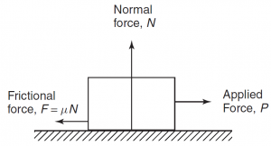**Estimated Force to drive buggy up the slope and across flat:**

**Estimated Forces: flat**

**Equation 1: ${F = C_{p}.m.g }^{}$ [1]**

**On the flat, assuming air resistance is negligible, the only frictional force is the surface the buggy is on given by figure 1.**

**The estimated forces were calculated using average of the static and rolling coefficient of friction using results from 4 different weights:**

* + - Average static friction coefficient = 0.092
    - Average Rolling friction coefficient = 0.082

**Using equation 1 and assuming the mass of the buggy is 1217 grams, the estimated needed forces are:**

* From stationary = 1.09N
* At constant speed = 0.978N

**NOTE:**

The measurements were taken using an analogue newton meter and as such the measurement for each force measurement were taken twice. As a result, these coefficients of friction exhibit low standard error:

* Rolling coefficient of friction = 0.502%
* Static coefficient of friction = 0.609%

Due to the low standard error, similar comparison gained by other groups and the simplicity of the experiment on the flat surface these results can be trusted to be accurate.

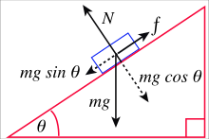**Estimated forces: slopes**

**Equation 2: $F=C_{p}.m.g.\cos{θ }+m.g.\sin{θ}$ [2]**

**This equation is described by the mechanics of forces on a ramp shown in figure 2.**

The following are the results for the measured coefficient of friction on the ramp:

* Average static friction = 0.142
* Average rolling friction = 0.126

Since the measurement of coefficient of friction on the ramp is generally inaccurate the flat coefficient of friction will be used. However, the static friction coefficient will be added to as error. This is because there are many different moving parts to a car on a ramp so a margin of error so to use the flat coefficient at a compromise.

The coefficient of static friction of ramp will be: 0.10

**Using the average rolling of ramp and static coefficient friction of flat,** **again assuming the estimated mass is 1217 grams, the forces are:**

From stationary = 8.08N

At constant speed= 4.13N

**Notes:**

**Required torque: flat and slopes**

**Equation 3: $T=F.r$ [3]**

**The Torque at a perimeter of circle is described by above relationship.**

**The required torque is now just a matter of using the relationship between the radius of the wheel and the force required;**

**Required torque for each stage:**

**Stationary to moving on flat:**

**Moving at constant speed on flat:**

**Stationary to moving on ramp:**

**Moving at constant speed on ramp:**

[3] https://en.wikipedia.org/wiki/Inclined_plane

|  |  |
| --- | --- |
| **Table of units** | |
| **m** | **Mass (g)** |
| **g** | **gravitational constant (ms^-2)** |
| **Cp** | **coefficient of friction** |
| **Theta** | **angle (degrees)** |
| **T** | **Torque (Nm)** |
| **F** | **Force (N)** |
| **r** | **Radius (m)** |

**Gear ratio selection**

One of the primary aims of the project is to allow the buggy move at the highest possible speed and simultaneously move up the highest incline available. As both speed and torque are inversely proportional, a mechanism is needed to balance this relationship in the most effective way. This mechanism is applied using a gearbox in which a connection is achieved between the electric motors and the buggy wheels. This linkage allows the output shaft operate at a lower speed than the input shaft. This compensation gives a mechanical benefit in terms of an increased torque at the output shaft. This allows the buggy to face no problems in climbing the maximum incline.

To illustrate the importance of the gearbox, an assumption is made that the given motors will solely drive the buggy, with no gearbox. As stated in section ???, the required wheel torque to go up the maximum incline is ${ T}_{3}= 0.183 Nm$. From the Torque-Current relationship in figure ???, the torque could be inserted in the equation:

$T=0.008I-0.0009 (4.1)$ giving a calculated current of $I=\frac{0.183 + 0.0009}{0.008}=22.99 A$.

Now, using the Voltage-Current relationship in figure ???, the required motor voltage:

$$V=2.4211×22.99+0.1568=55.81 V (4.2)$$

These values reveal the required current and voltage to move the buggy up the ramp using just the motors, which explains the necessity of the gearbox which certainly reduces these current/voltage values into much convenient numbers.

**Required gear ratio**

Referring to figure ???, the maximum available torque produced by the motor is T = 0.01 Nm at constant motor voltage of V = 5 V. This value is available at the maximum permissible current of 1.4 A. However, to avoid any risks, a safety margin is taken to assume no operation occurs at 1.4 A. Instead, the available motor torque is assumed to be at 1.23 A and so by reading the graph in figure ???, this gives a motor torque of $T_{1}=0.009 Nm$.

As before, required wheel torque is ${ T}_{3}= 0.183 Nm$. As a result, the gear ratio formula could be used: $atio= \frac{T_{3}}{T_{1}} (4.3)$. Using (4.3), required gear ratio is $io= \frac{0.183}{0.009}=20.3$.

**Chosen gearbox**

The design of the available gearboxes compromises of two gear stages, each with an efficiency of 85% giving an overall estimated efficiency of $η={0.85}^{2}=0.7725.$ Four gear wheels form the whole system including gear wheel 1 on the input shaft, gear wheels 2A and 2B both on the common shaft and gear wheel 3 on the output shaft. Figure ??? illustrates this, accompanied with the gear ratio formula.

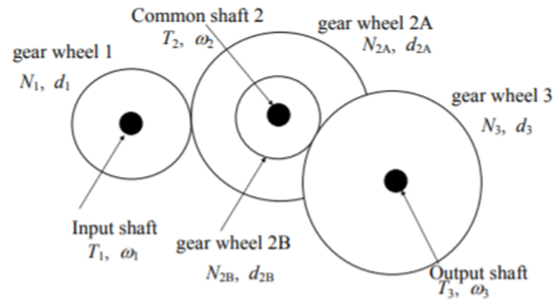

$$\frac{T_{3}}{T_{1}}= η\frac{N_{3}N_{2A}}{N_{2B}N_{1}} (4.4)$$

Figure ??? Common gear wheels on one shaft [1]

The following table, table ???, compares the 3 different gearbox options available, alongside their respective calculated gear ratios, taking into account the efficiency.

Table ??? Gear ratio comparison

|  |  |  |  |  |  |
| --- | --- | --- | --- | --- | --- |
| Option no. | $$N_{1}$$ | $$N_{2A}$$ | $$N_{2B}$$ | $$N_{3}$$ | Gear ratio using (4.4) |
| 1 | 16 | 48 | 12 | 48 | $$0.7725×\frac{48×48}{12×16}= 9.27$$ |
| 2 | 16 | 50 | 10 | 48 | $$0.7725×\frac{48×50}{10×16}= 10.84$$ |
| 3 | 16 | 50 | 10 | 60 | $$0.7725×\frac{60×50}{10×16}= 13.55$$ |

Consequently, gearbox 3 is the chosen option due its gear ratio being the nearest to the required gear ratio, calculated above.

**Intermediate shaft position**

To achieve the required intermediate shaft position, the Pitch Circle Diameter (PCD) needs to be calculated, using the following formula: $PCD=no. of teeth ×MOD \left(4.5\right).$ In this case all gears are 0.5 mm module. For gearbox 3, using (4.5), PCD(1) = 8 and PCD(2A) = 25.

Furthermore, the x-coordinate of the center of the intermediate shaft, with respect to gear wheel 1 center, is calculated using the formula

$x=\frac{PCD\left(1\right)+PCD\left(2A\right)}{2}+0.1 mm= \frac{8 + 25}{2}+0.1= 16.6 mm$

**Maximum speed**

From figure ??? above, at 1.23 A, the motor speed is measured to be $ω_{1}= 2221 rpm.$ Using the following torque-speed relationship $ω_{3}= \frac{ω_{1}×T_{1}}{T_{3}} \left(4.6\right)$, the maximum speed calculated is $ω_{3}= \frac{2221 ×0.009}{0.183}=109.23 rpm.$